EXPERIMENT-04 DHILIPAN M
21/07/2026 192411038

CRIPT-ARITHMETIC PROBLEM USING BACKTRACKING
AIM:
To write a Python program to solve the Crypt-Arithmetic Problem using Backtracking.
ALGORITHM:
Step 1: Read the crypt-arithmetic equation (e.g., SEND + MORE = MONEY).
Step 2: Identify all unique letters used in the equation.
Step 3: Assign digits (0–9) to each letter without repetition.
Step 4: Ensure that no leading letter is assigned the digit 0.
Step 5: Check whether the assigned digits satisfy the arithmetic equation.
Step 6: Display the valid digit assignment if a solution exists; otherwise, display "No Solution Found."
PROGRAM:
from itertools import permutations
letters = ('S', 'E', 'N', 'D', 'M', 'O', 'R', 'Y')
for p in permutations(range(10), 8):
S, E, N, D, M, O, R, Y = p
if S == 0 or M == 0:
continue
send = 1000*S + 100*E + 10*N + D
more = 1000*M + 100*O + 10*R + E
money = 10000*M + 1000*O + 100*N + 10*E + Y
if send + more == money:
print("Solution Found")
print("S =", S)
print("E =", E)
print("N =", N)
print("D =", D)
print("M =", M)
print("O =", O)
print("R =", R)
print("Y =", Y)
print("\n", send, "+", more, "=", money)
break
else:
print("No Solution Found")

OUTPUT:

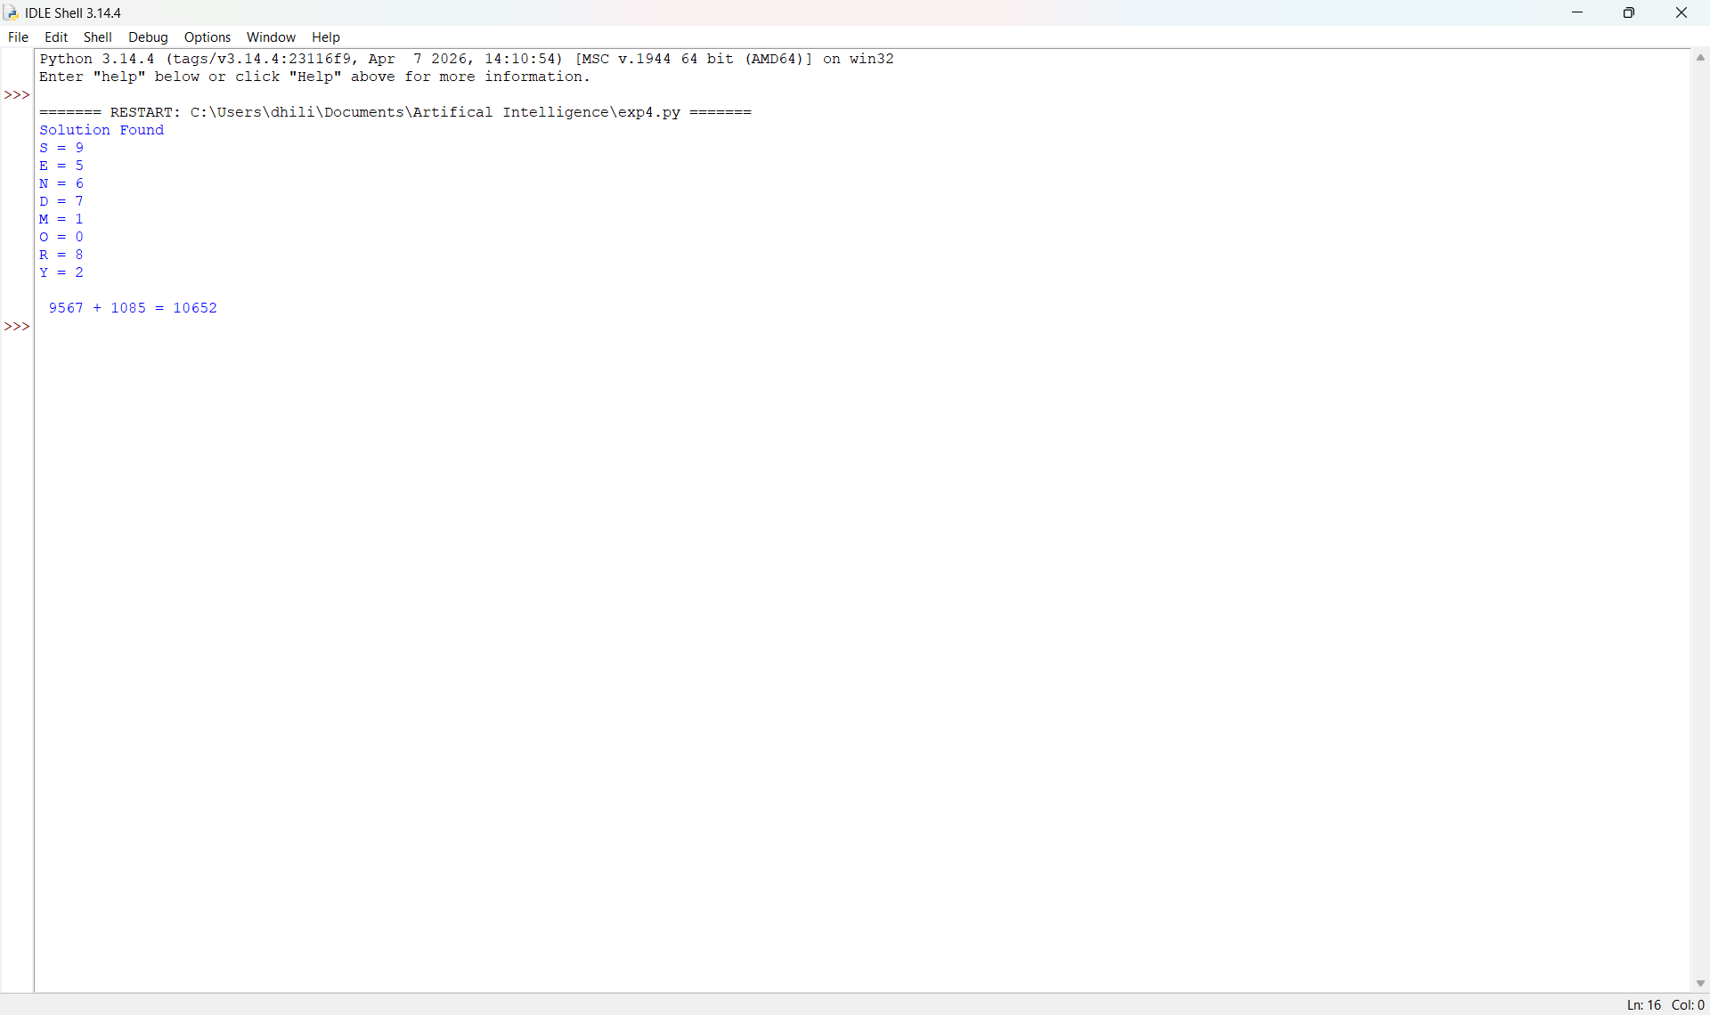

RESULT:
Thus, the Python program to solve the Crypt-Arithmetic Problem using the Backtracking algorithm was implemented successfully and the required output was obtained.

